**#INTRODUCTION**

**\*Objectives of this ATM management project is to perform following Operations**

**1. Efficient Cash Withdrawal and Deposit Management**

**- Facilitate quick and secure *cash withdrawals* and *deposits* for users.**

**- Ensure that ATM balances are maintained and transactions are recorded properly.**

**2. Balance Inquiry and Mini Statements**

**- Allow users to check their *account balance* in real-time.**

**- Provide *mini-statements* summarizing recent transactions for user convenience.**

**3. Card Management**

**- Debit card operations like PIN change.**

**4. Transaction Limits and Alerts**

**- Impose Transaction limits for security and regulatory compliance.**

**5.Fast Cash Option**

**- Fast cash operation provides the user given choices of the amount for the withdrawal**

**#DATABASE DESIGN**

**Tables and Attributes**

1. **Table: signup**
   * form_no (PK, varchar(30))
   * name (varchar(30))
   * father_name (varchar(30))
   * DOB (varchar(20))
   * gender (varchar(30))
   * email (varchar(60))
   * marital_status (varchar(30))
   * address (varchar(60))
   * city (varchar(30))
   * pincode (varchar(30))
   * state (varchar(30))
2. **Table: tablesignuptwo**
   * form_no (PK, varchar(30))
   * religion (varchar(30))
   * category (varchar(30))
   * income (varchar(20))
   * education (varchar(30))
   * occupation (varchar(60))
   * pan (varchar(30))
   * aadhar (varchar(60))
   * siniorcitizen (varchar(30))
   * existing_account (varchar(30))
3. **Table: signupthree**
   * form_no (PK, varchar(30))
   * account_type (varchar(30))
   * card_number (varchar(30))
   * pin (varchar(30))
   * facility (varchar(30))
4. **Table: login**
   * form_no (PK, varchar(30))
   * card_number (varchar(30))
   * pin (varchar(30))
5. **Table: bank**
   * pin (PK, varchar(20))
   * date (varchar(50))
   * type (varchar(20))
   * amount (varchar(20))

**\*Relationships**

1. **One-to-One Relationship**:
   * signup → tablesignuptwo
     + signup.form_no = tablesignuptwo.form_no
   * signup → signupthree
     + signup.form_no = signupthree.form_no
   * signup → login
     + signup.form_no = login.form_no
   * signupthree → login
     + signupthree.card_number = login.card_number
     + signupthree.pin = login.pin
2. **One-to-Many Relationship**:
   * login → bank
     + login.pin = bank.pin

+-------------------+ +--------------------+

| signup | | signuptwo |

+-------------------+ +--------------------+

| form_no (PK) |<------| form_no (PK) |

| name | | religion |

| father_name | | category |

| DOB | | income |

| gender | | education |

| email | | occupation |

| marital_status | | pan |

| address | | aadhar |

| city | | siniorcitizen |

| pincode | | existing_account |

| state | +--------------------+

+-------------------+

|

|

v

+-------------------+ +--------------------+

| signupthree | | login |

+-------------------+ +--------------------+

| form_no (PK) |<------| form_no (PK) |

| account_type | | card_number |

| card_number | | pin |

| pin | +--------------------+

| facility |

+-------------------+

|

|

V

+-------------------+

| bank |

+-------------------+

| pin (PK) |

| date |

| type |

| amount |

+-------------------+

**ATM Management System (ER- Diagram)**



Additional Details



Account Details

Personal Details

Correspo-nds

Mini-Statement

Have

Correspo-nds

Login

Correspo-nds

**\*INPUT AND OUPUT SCREENS**



**1.Login Screen -**

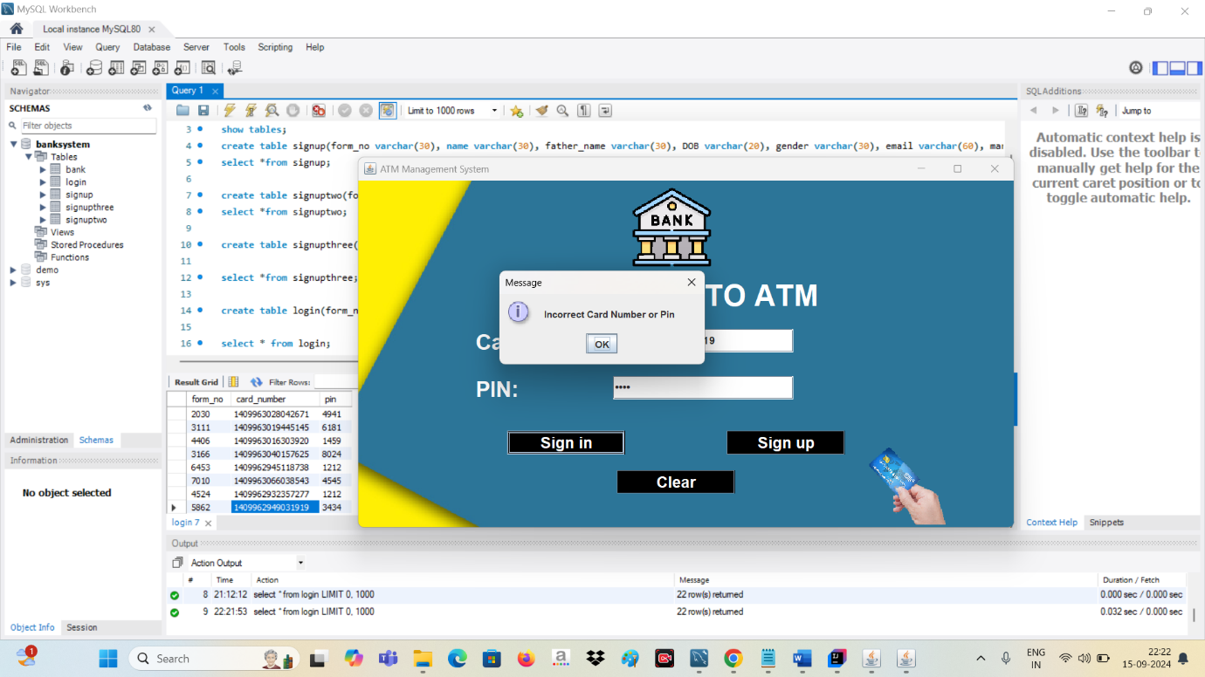

**2.Sign UP form -**

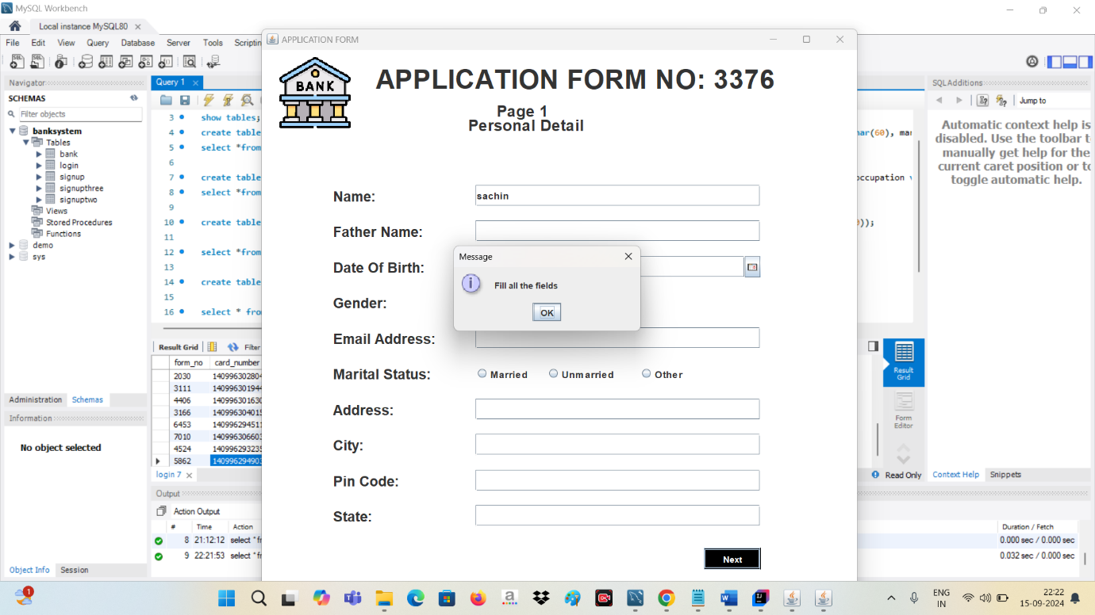

1. **Sign Up 2 -**

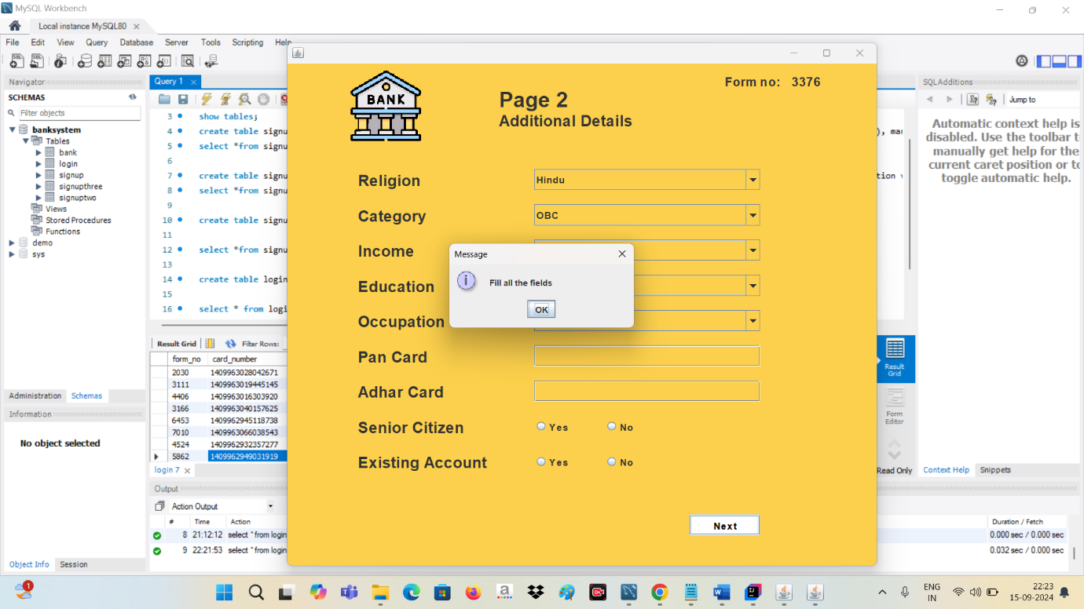

1. **Sign Up 3 -**

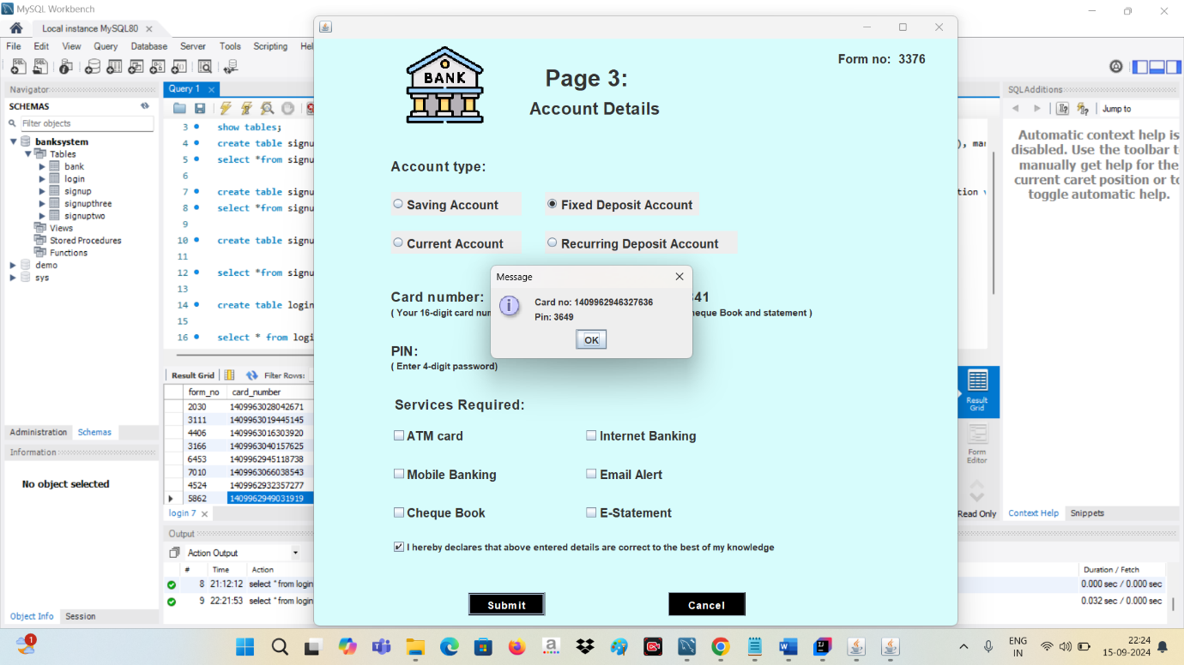

1. **Main Transaction Screen -**

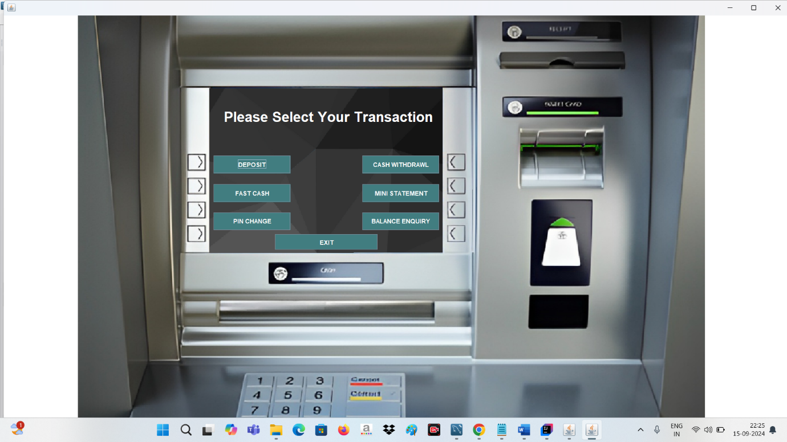

1. **Deposit Screen -**

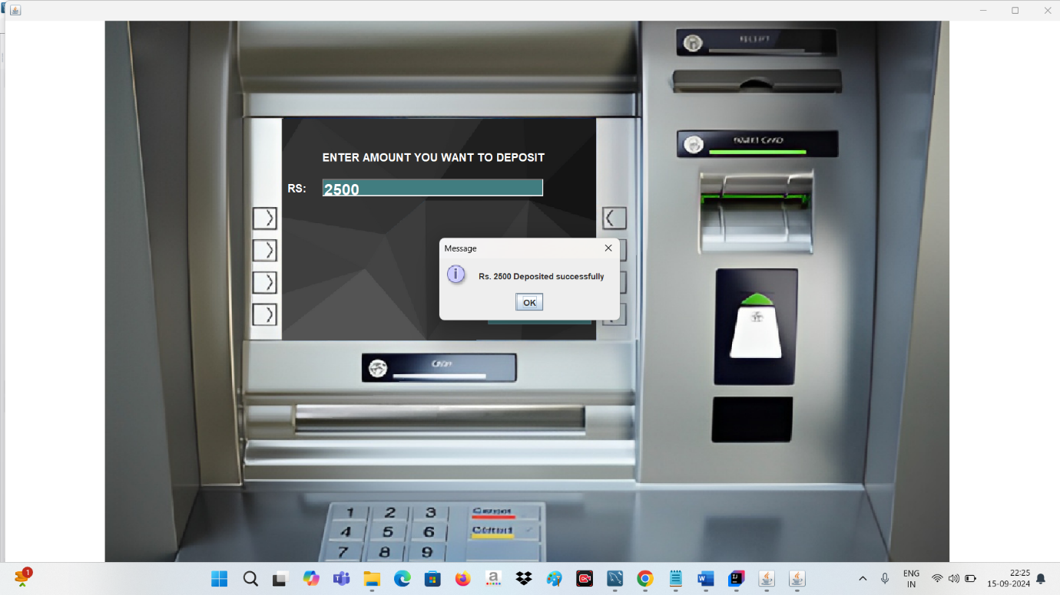

1. **Withdrawal Screen -**

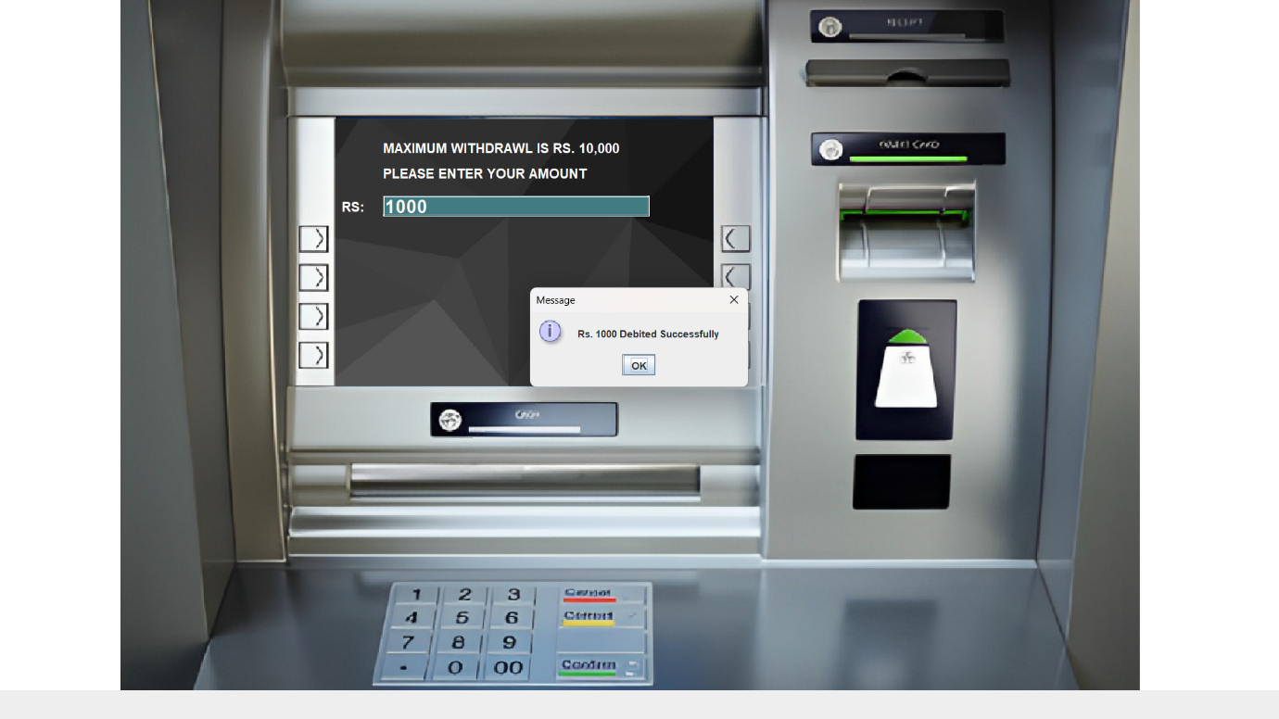

1. **Fast Cash Screen -**

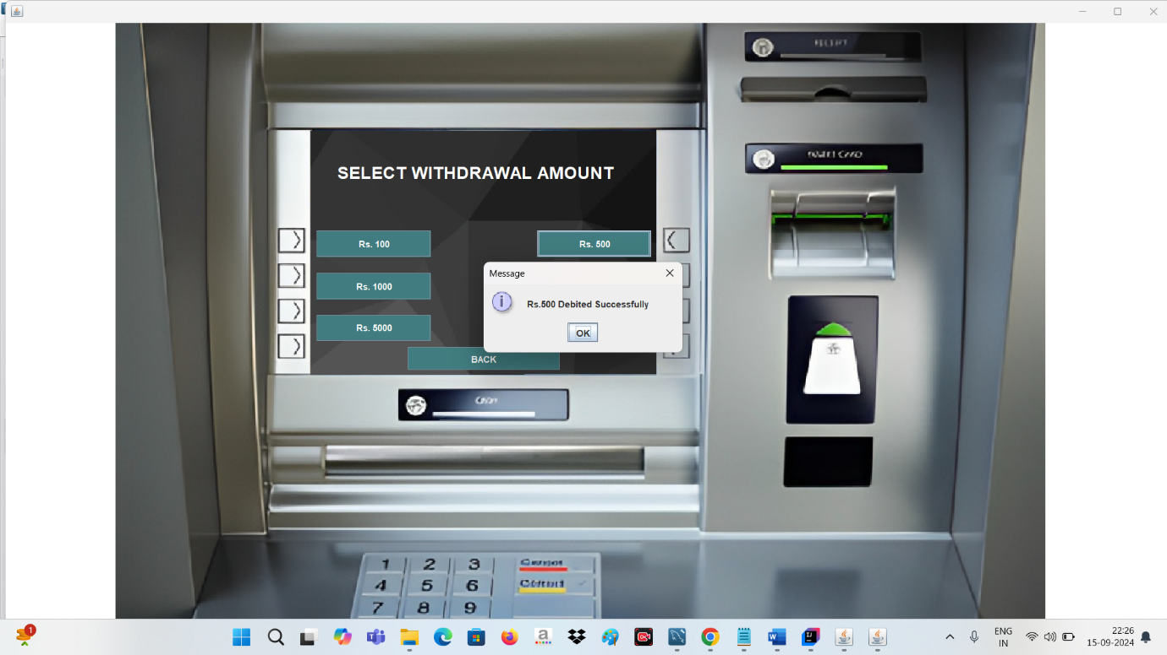

**9.Mini Statement Screen -**

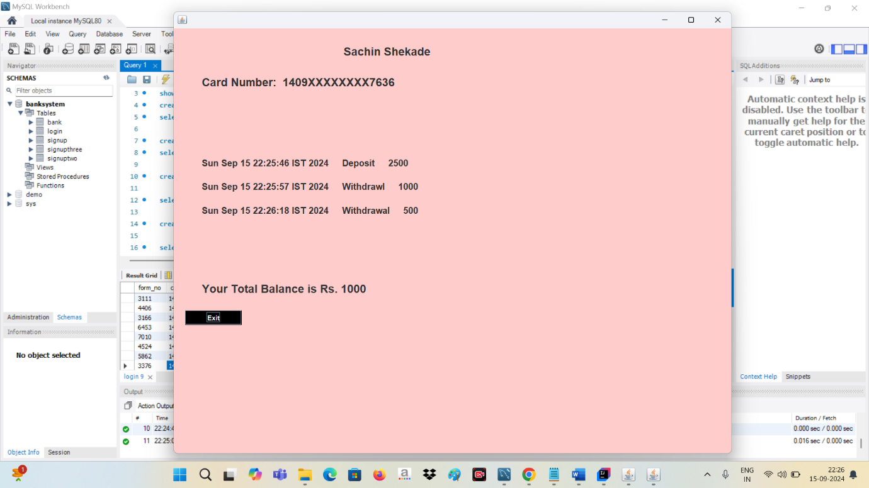

1. **Change Pin Screen -**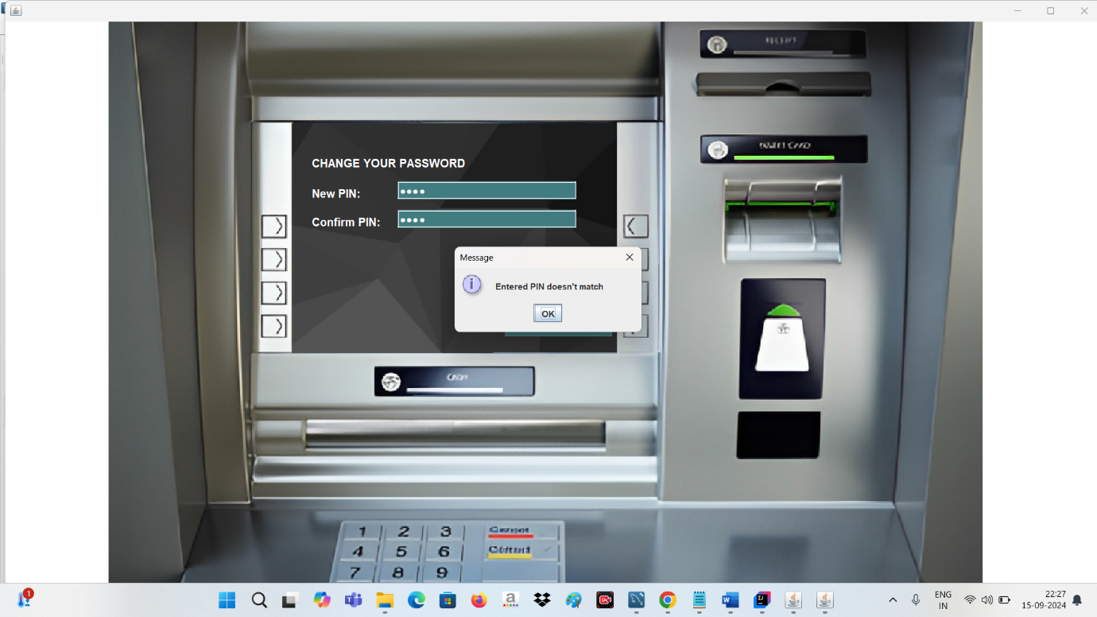

**10.Change Pin Screen -**

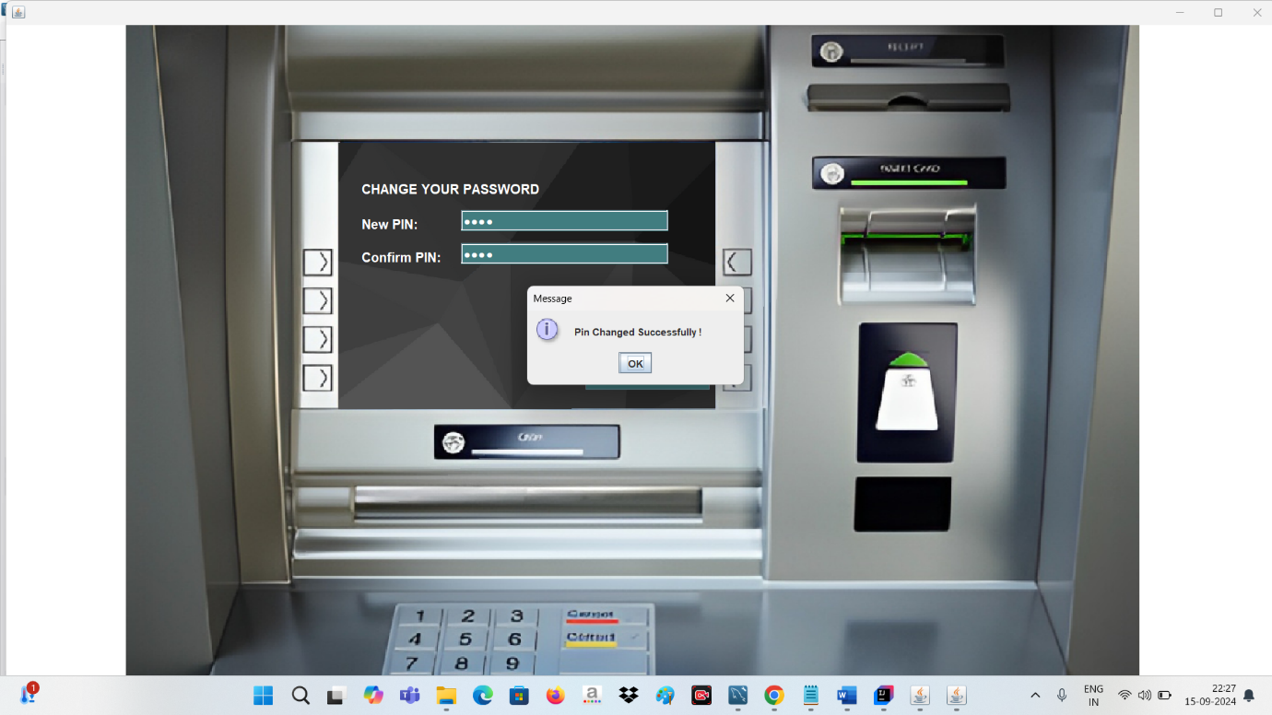

**11.Balance Enquiry Screen -**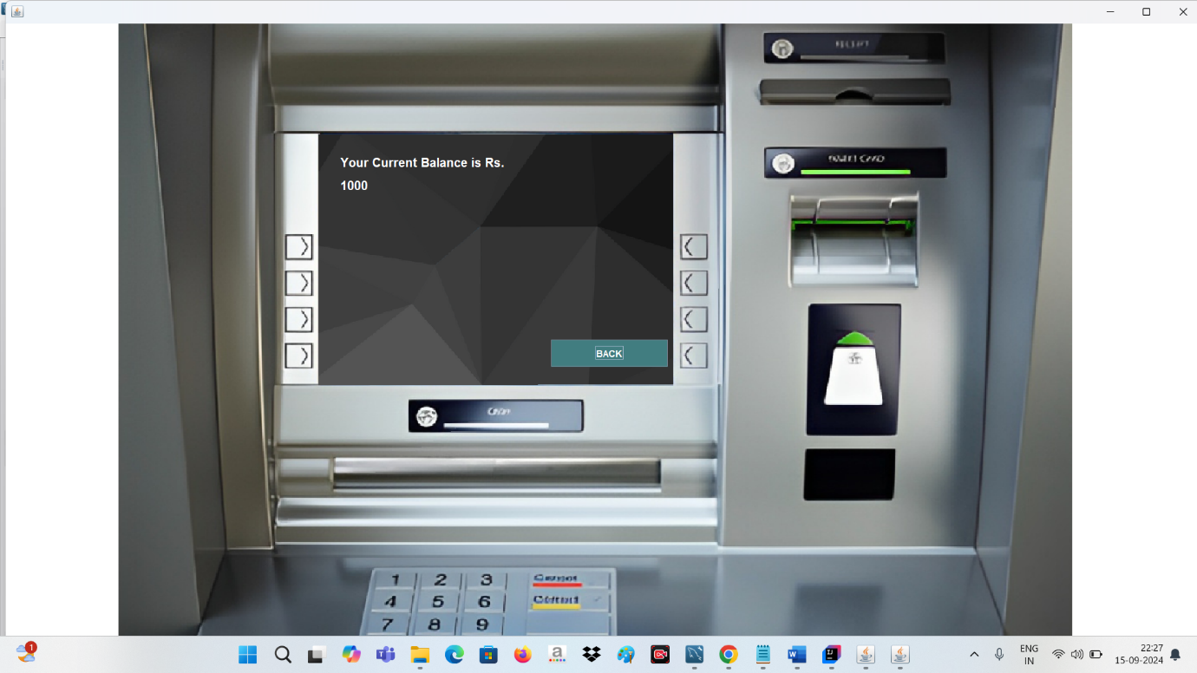

**12. Exit from Main-transaction Screen -**

